Git and github – 02
- Install git.

2. Create a repo in github with README.md and .ignore file.
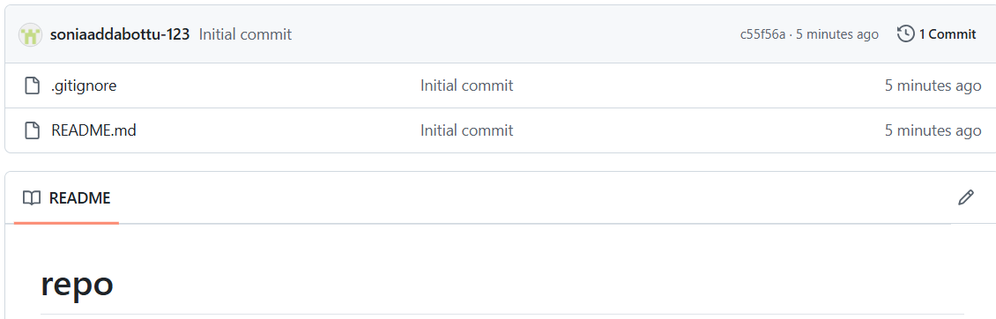
- Clone the created repo to local.
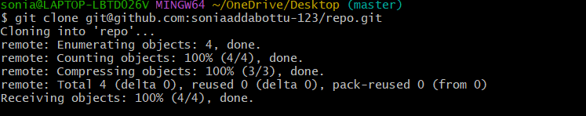
- Create two files in local repo.
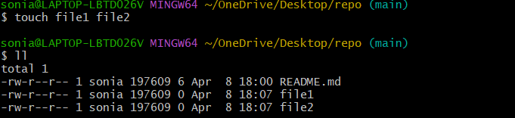
- Commit two files and push to central Repository.

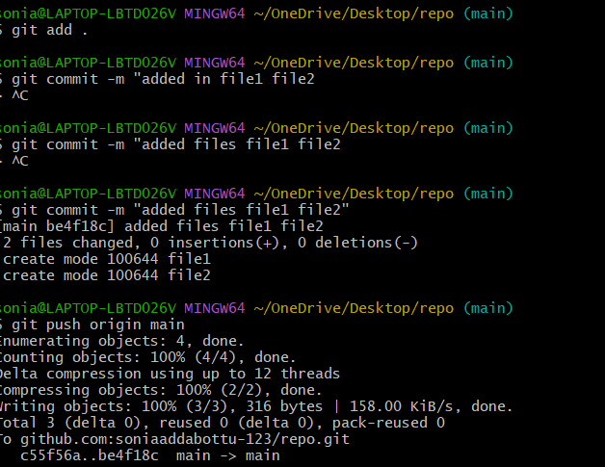

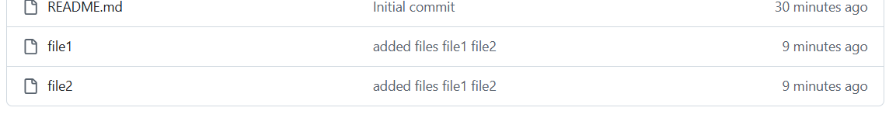

6.Create a branch in local and create a sample file and push to central.

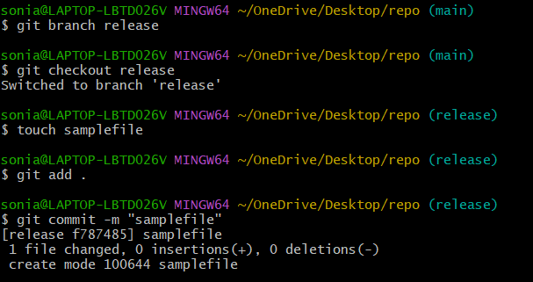
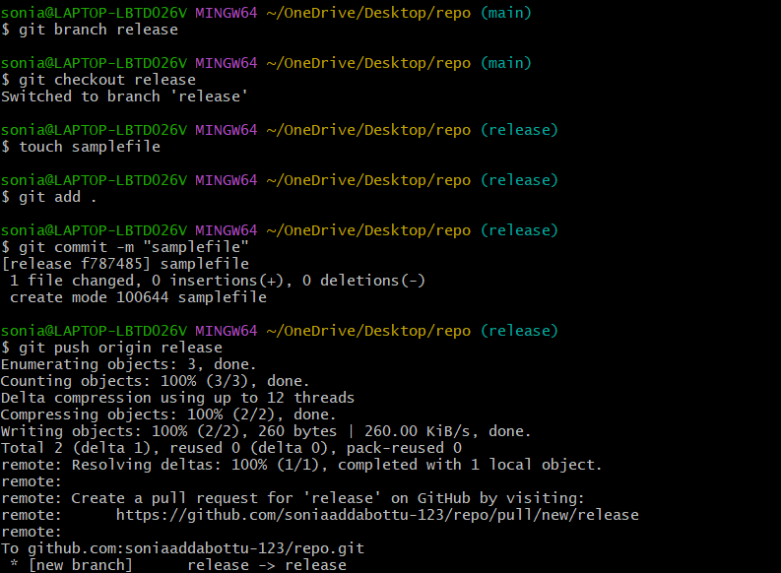

7.Create a branch in github and clone that to local.

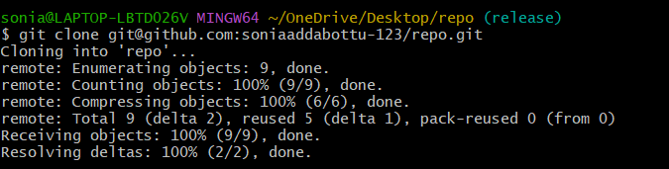

8.Merge the created branch with master in git local.
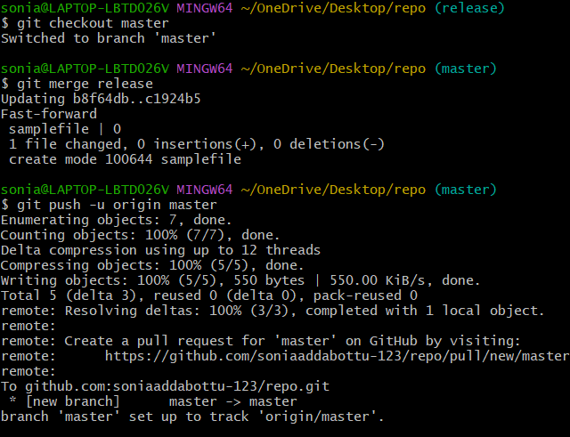
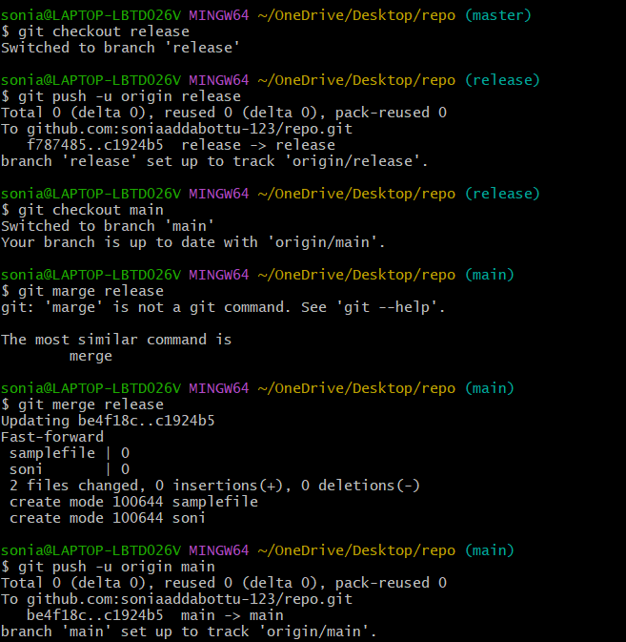
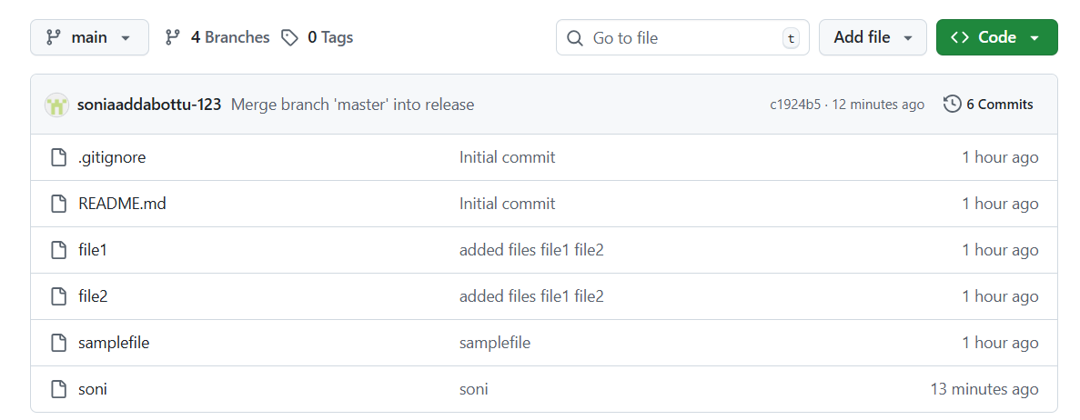

- Merge the created branch with master in github by sending a pull request.
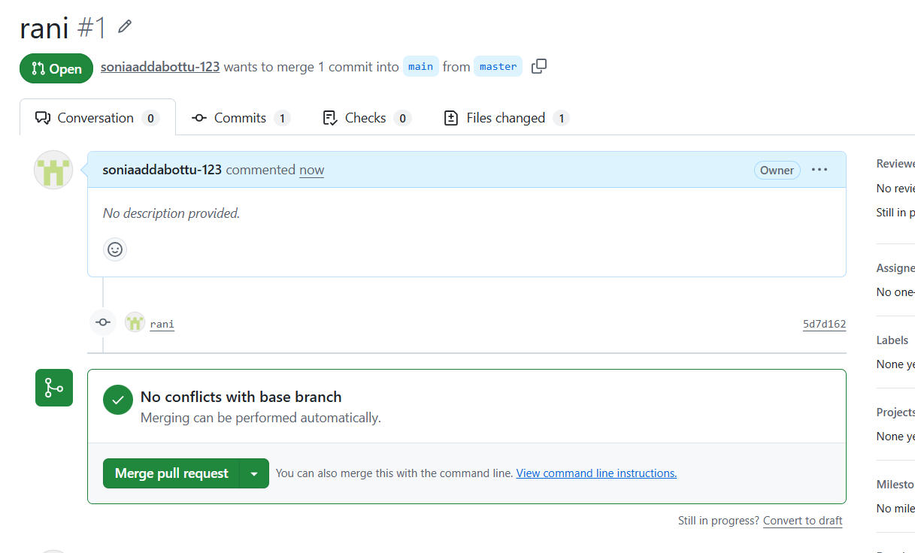
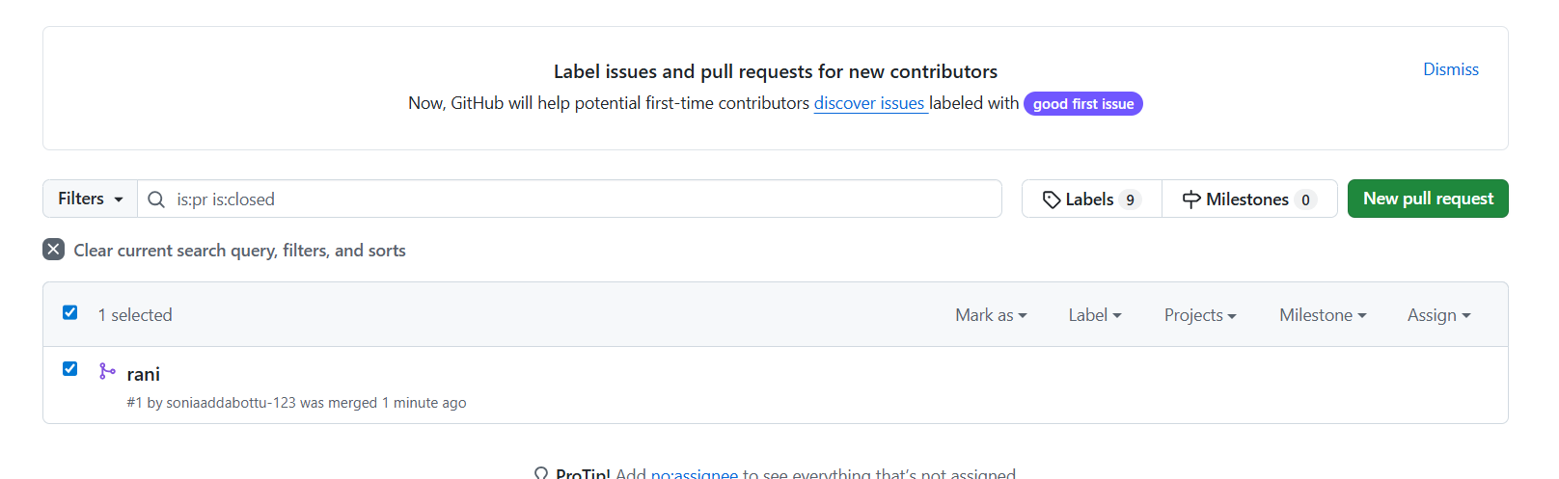

10.Create a file in local and send that to branch in github.
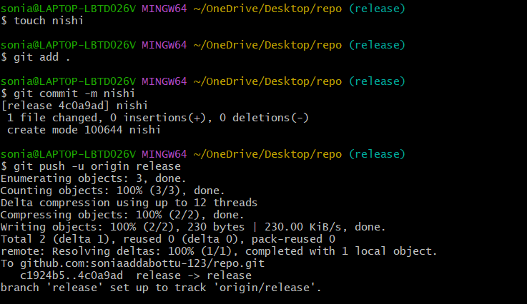
11.Clone only a branch from github to local.

- Create a file with all passwords and make that untrackable with git.
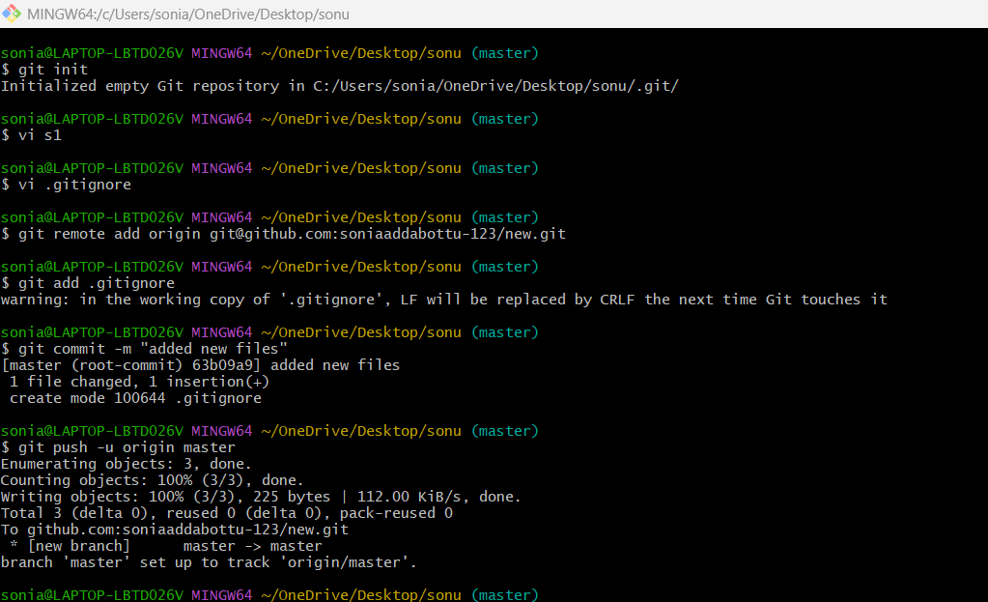
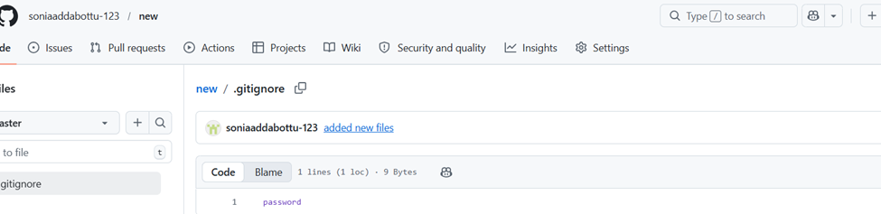

13. Make a commit and make that commit reset without savings changes.
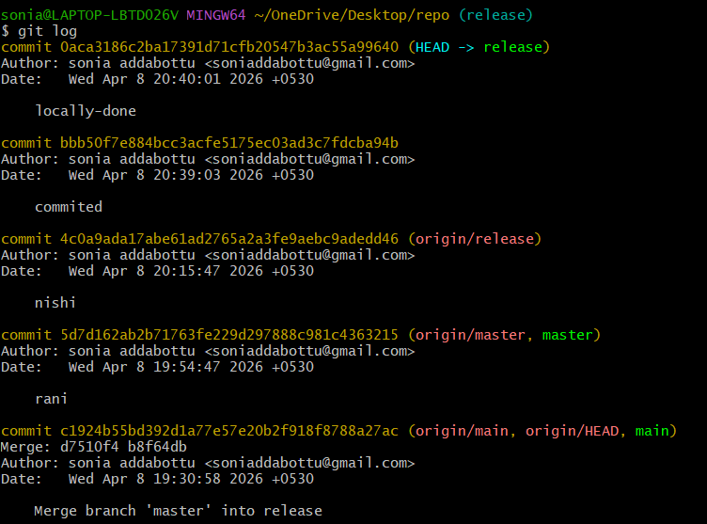
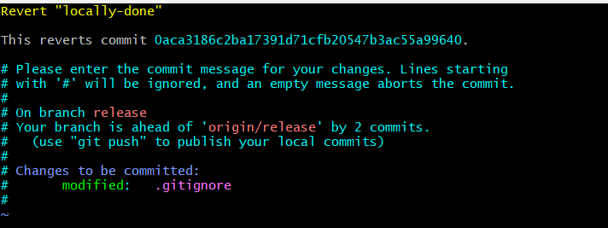

14.Revert a commited commit to the older version

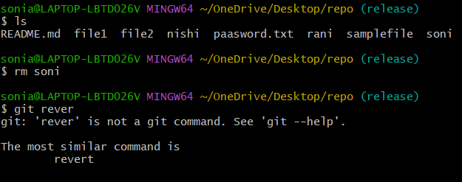

15. Push a file to stash without savings the changes and work on another file.
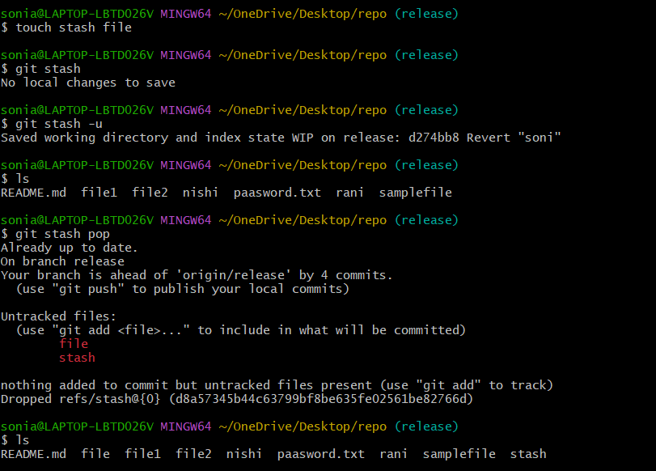
16.Undo the stash file and start working on that again.
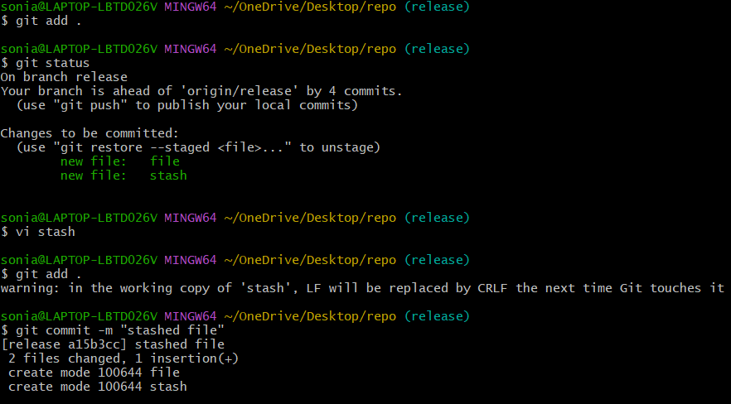

17.Generate a ssh-keygen and configure into github.
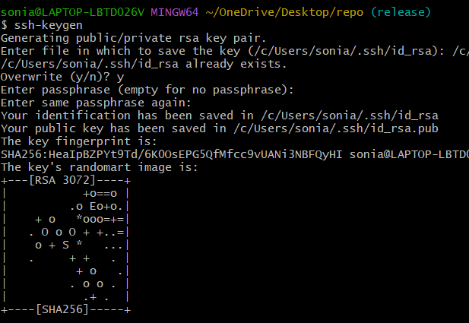
18.Configure webhooks to github.
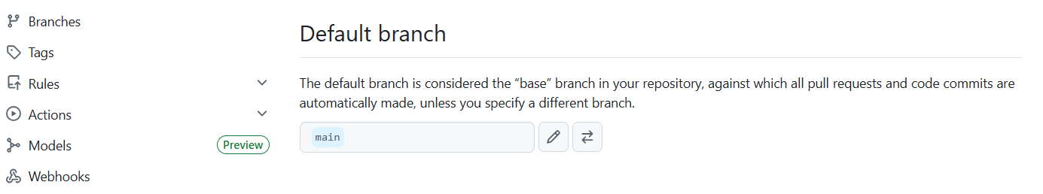
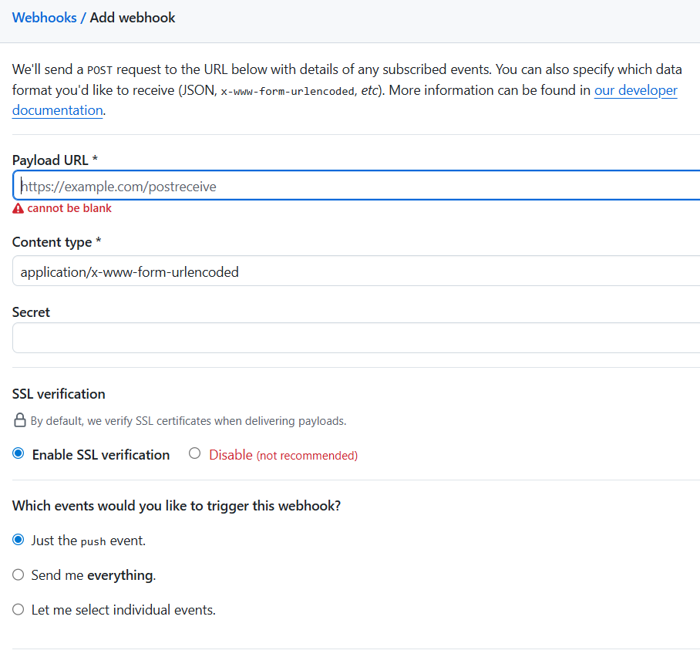
We can give any configuration we can do
- Basic understanding of .git file.

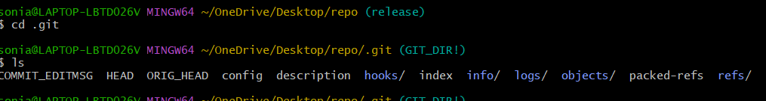
20.Check all the logs of git..
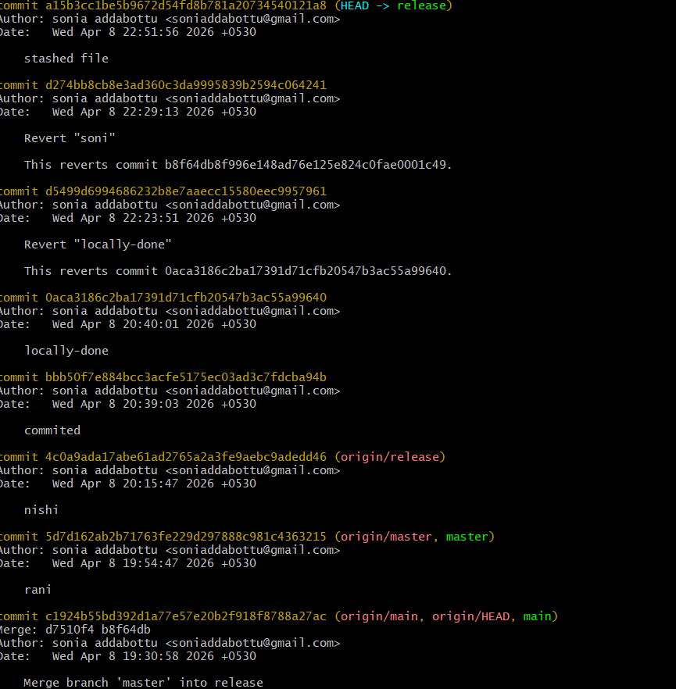
21.Rename the commit message.
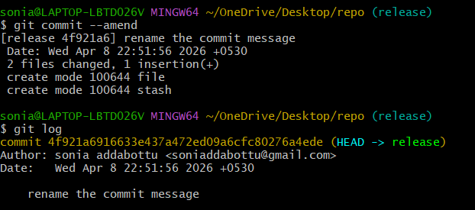
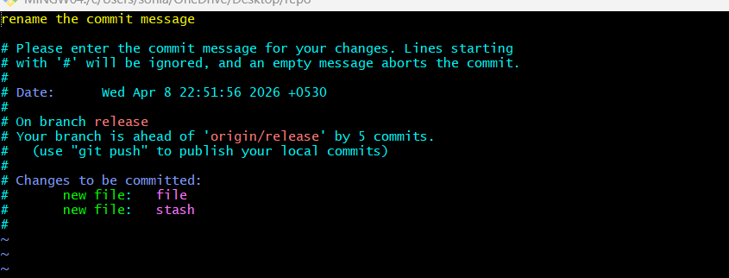
22.Merge multiple commits into single commit.
